Data Communication Network Basis



Huawei Technologies Co., Ltd.

|  |
| --- |
| **Copyright © Huawei Technologies Co., Ltd. 2020. All rights reserved.**  No part of this document may be reproduced or transmitted in any form or by any means without prior written consent of Huawei Technologies Co., Ltd.  **Trademarks and Permissions**  HW_POS_RBG_Vertical-150ppi.png and other Huawei trademarks are trademarks of Huawei Technologies Co., Ltd.  All other trademarks and trade names mentioned in this document are the property of their respective holders.  **Notice**  The purchased products, services and features are stipulated by the contract made between Huawei and the customer. All or part of the products, services and features described in this document may not be within the purchase scope or the usage scope. Unless otherwise specified in the contract, all statements, information, and recommendations in this document are provided "AS IS" without warranties, guarantees or representations of any kind, either express or implied.  The information in this document is subject to change without notice. Every effort has been made in the preparation of this document to ensure accuracy of the contents, but all statements, information, and recommendations in this document do not constitute a warranty of any kind, express or implied. |

|  |  |
| --- | --- |
| Huawei Technologies Co., Ltd. | |
| Address: | Huawei Industrial Base  Bantian, Longgang  Shenzhen 518129  People's Republic of China |
| Website: | <https://e.huawei.com/> |

**Huawei Certification System**

Huawei Certification follows the "platform + ecosystem" development strategy, which is a new collaborative architecture of ICT infrastructure based on "Cloud-Pipe-Terminal". Huawei has set up a complete certification system consisting of three categories: ICT infrastructure certification, platform and service certification, and ICT vertical certification. It is the only certification system that covers all ICT technical fields in the industry. Huawei offers three levels of certification: Huawei Certified ICT Associate (HCIA), Huawei Certified ICT Professional (HCIP), and Huawei Certified ICT Expert (HCIE). Huawei Certification covers all ICT fields and adapts to the industry trend of ICT convergence. With its leading talent development system and certification standards, it is committed to fostering new ICT talent in the digital era, and building a sound ICT talent ecosystem.

Huawei Certified ICT Associate-Datacom (HCIA-Datacom) is designed for Huawei's frontline engineers and anyone who want to understand Huawei's datacom products and technologies. The HCIA-Datacom certification covers routing and switching principles, basic WLAN principles, network security basics, network management and O&M basics, SDN and programmability and automation basics.

The Huawei certification system introduces the industry, fosters innovation, and imparts cutting-edge datacom knowledge.

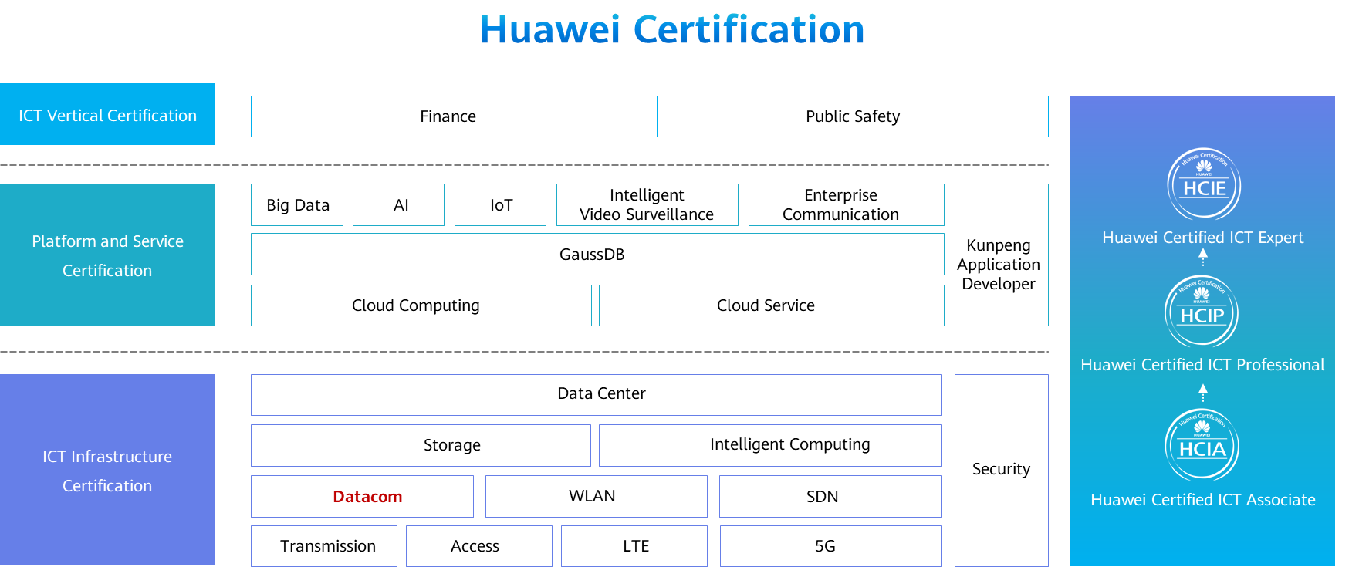

Contents

[1 Data Communication Network Basis 1](#_Toc59713901)

[1.1 Foreword 1](#_Toc59713902)

[1.2 Objectives 1](#_Toc59713903)

[1.3 Huawei Device Icons 2](#_Toc59713904)

[1.3.1 Huawei Device Icons 2](#_Toc59713905)

[1.4 Communication and Networks 2](#_Toc59713906)

[1.4.1 Concept of Network Communication 2](#_Toc59713907)

[1.4.2 Information Transfer Process 3](#_Toc59713908)

[1.4.3 Common Terms 5](#_Toc59713909)

[1.4.4 Concept of the Data Communication Network 6](#_Toc59713910)

[1.4.5 Switches 6](#_Toc59713911)

[1.4.6 Routers 7](#_Toc59713912)

[1.4.7 Firewalls 7](#_Toc59713913)

[1.4.8 Wireless devices 8](#_Toc59713914)

[1.5 Network Types and Topology Types 9](#_Toc59713915)

[1.5.1 LAN, MAN, and WAN 9](#_Toc59713916)

[1.5.2 LAN, MAN, and WAN in the Education Industry 10](#_Toc59713917)

[1.5.3 Network Topologies 10](#_Toc59713918)

[1.5.4 Network Topology Types 11](#_Toc59713919)

[1.6 Network Engineering and Network Engineers 13](#_Toc59713920)

[1.6.1 Network Engineering 13](#_Toc59713921)

[1.6.2 Network Engineer 13](#_Toc59713922)

[1.6.3 Network Engineers' Technology Development Path 14](#_Toc59713923)

[1.6.4 Huawei Certification Injects Vitality into Talent Development for Enterprises 14](#_Toc59713924)

[1.6.5 Huawei Certification Portfolio 14](#_Toc59713925)

[1.6.6 Huawei Datacom Certification Portfolio 15](#_Toc59713926)

[1.7 Quiz 16](#_Toc59713927)

[1.8 Summary 17](#_Toc59713928)

# Data Communication Network Basis

## Foreword

Communication has always been with us ever since the origin of human society. Communication has been playing an increasingly important role especially since human society entered the information era in the 1970s or 1980s.

The communication mentioned in this course refers to the communication implemented through a data communication network. This course describes the concepts related to communication and a data communication network, information transfer process, network devices and their functions, network types, and typical networking. In addition, this course briefly introduces the concepts related to network engineering and network engineers.

## Objectives

On completion of this course, you will be able to:

Understand the concepts related to communication and a data communication network.

Be able to describe the information transfer process.

Differentiate network devices of different types and understand their basic functions.

Understand different network types and topology types.

Understand the concepts related to network engineering and network engineers.

## Huawei Device Icons

### Huawei Device Icons

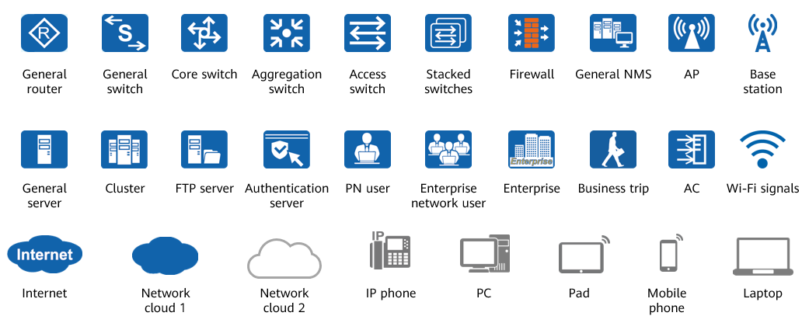

Huawei Device Icons

## Communication and Networks

### Concept of Network Communication

Communication refers to the information transfer and exchange between people, between people and things, and between things through a certain medium and behavior.

Network communication refers to communication between terminal devices through a computer network.

Examples of network communication:

A. Two computers connected with a network cable form the simplest network.

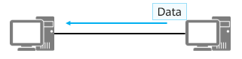

Files are transferred between two computers (terminals) through a network cable.

B. A small network consists of a router (or switch) and multiple computers. In such a network, files can be freely transferred between every two computers through the router or switch.

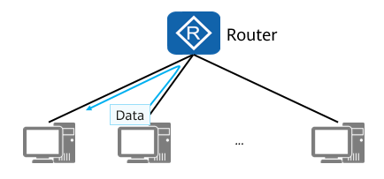

Files are transferred among multiple computers (terminals) through a router

C. To download a file from a website, a computer must first access the Internet.

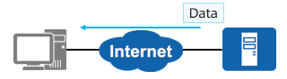

A computer (terminal) downloads files through the Internet

The Internet is the largest computer network in the world. Its predecessor, Advanced Research Projects Agency Network (ARPAnet), was born in 1969. The wide popularization and application of the Internet is one of the landmarks of the information age.

### Information Transfer Process

Virtual information transfer is similar to real object transfer.

Comparison between express delivery (object transfer) and network communication:

Objects to be delivered by express delivery:

The application generates the information (or data) to be delivered.

The objects are packaged and attached with a delivery form containing the name and address of the consignee.

The application packs the data into the original "data payload", and adds the "header" and "tail" to form a packet. The important information in the packet is the address information of the receiver, that is, the "destination address".

The process of adding some new information segments to an information unit to form a new information unit is called encapsulation.

The package is sent to the distribution center, where packages are sorted based on the destination addresses and the packages destined for the same city are placed on the same plane.

The packet reaches the gateway through the network cable. After receiving the packet, the gateway decapsulates the packet, reads the destination address, and then re-encapsulates the packet. Then, the gateway sends the packet to a router based on the destination address. After being transmitted through the gateway and router, the packet leaves the local network and enters the Internet for transmission.

The network cable functions similarly as the highway. The network cable is the medium for information transfer.

Upon arrival at the destination airport, packages are taken out for sorting, and those destined for the same district are sent to the same distribution center.

After the packet reaches the local network where the destination address resides through the Internet, the gateway or router of the local network decapsulates and encapsulates the packet, and then sends the packet to the next router according to the destination address. Finally, the packet reaches the gateway of the network where the destination computer resides.

The distribution center sorts the packages based on the destination addresses. Couriers deliver packages to recipients. Each recipient unpacks the package and accepts the package after confirming that the objects are intact, indicating that the whole delivery process is complete.

After the packet reaches the gateway of the network where the destination computer resides, the packet is decapsulated and encapsulated, and then sent to the corresponding computer according to the destination address. After receiving the packet, the computer verifies the packet. If the packet passes the verification, the computer accepts the packet and sends the data payload to the corresponding application for processing, indicating that the network communication process ends.

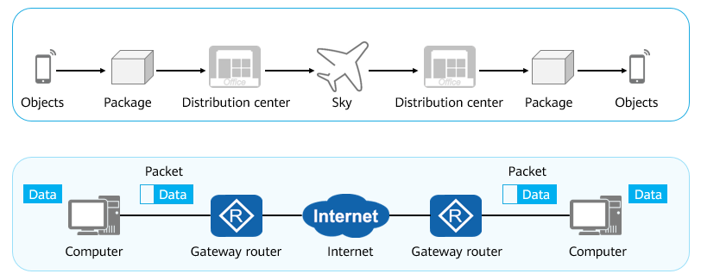

Information Transfer Process

### Common Terms

Common Terms

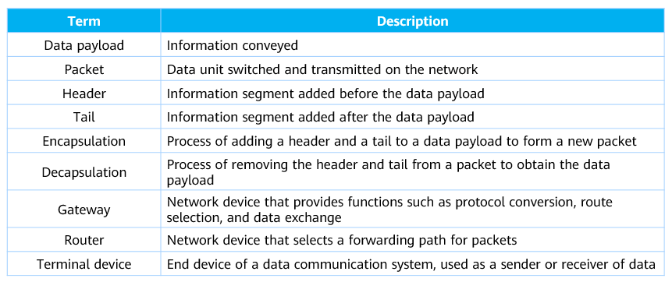

Data payload: It can be considered as the information to be transmitted. However, in a hierarchical communication process, the data unit (packet) transmitted from the upper layer to the lower layer can be called the data payload of the lower layer.

Packet: a data unit that is exchanged and transmitted on a network. It is in the format of header+data payload+tail. During transmission, the format and content of packets may change.

Header: The information segment added before the data payload during packet assembly to facilitate information transmission is called the packet header.

Tail: The information segment added after the payload to facilitate information transmission is called the tail of a packet. Note that many packets do not have tails.

Encapsulation: A technology used by layered protocols. When the lower-layer protocol receives a message from the upper-layer protocol, the message is added to the data part of the lower-layer frame.

Decapsulation: It is the reverse process of encapsulation. That is, the header and tail of a packet are removed to obtain the data payload.

Gateway: A gateway is a network device that provides functions such as protocol conversion, route selection, and data exchange when networks using different architectures or protocols communicate with each other. A gateway is a term that is named based on its deployment location and functionality, rather than a specific device type.

Router: a network device that selects a transmission path for a packet.

Terminal device: It is the end device of the data communication system. As the data sender or receiver, the terminal device provides the necessary functions required by the user access protocol operations. The terminal device may be a computer, server, VoIP, or mobile phone.

### Concept of the Data Communication Network

Data communication network: Communication network that consists of routers, switches, firewalls, access controllers (ACs), access points (APs), PCs, network printers, and servers.

Function: To implement data communication

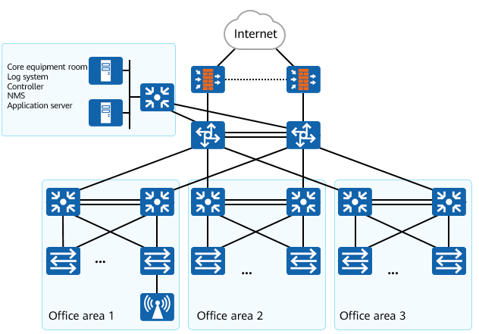

Data Communication Network

### Switches

On a campus network, a switch is the device closest to end users and is used to connect terminals to the campus network. Switches at the access layer are usually Layer 2 switches and are also called Ethernet switches. Layer 2 refers to the data link layer of the TCP/IP reference model.

The Ethernet switch can implement the following functions: data frame switching, access of end user devices, basic access security functions, and Layer 2 link redundancy.

Broadcast domain: A set of nodes that can receive broadcast packets from a node.

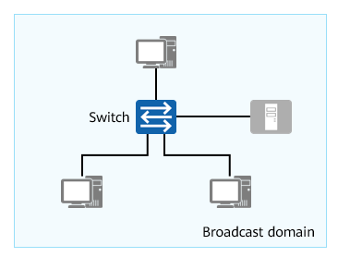

Switches

### Routers

Router: a network-layer device that forwards data packets on the Internet. Based on the destination address in a received packet, a router selects a path to send the packet to the next router or destination. The last router on the path is responsible for sending the packet to the destination host.

Implementing communication between networks of the same type or different types

Isolating broadcast domains

Maintaining the routing table and running routing protocols

Selecting routes and forwarding IP packets

Implementing WAN access and network address translation

Connecting Layer 2 networks established through switches

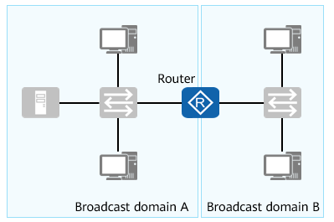

Routers

### Firewalls

Firewall: a network security device used to ensure secure communication between two networks. It monitors, restricts, and modifies data flows passing through it to shield information, structure, and running status of internal networks from the public network.

Isolating networks of different security levels

Implementing access control (using security policies)   
between networks of different security levels

Implementing user identity authentication

Implementing remote access

Supporting data encryption and VPN services

Implementing network address translation

Implementing other security functions

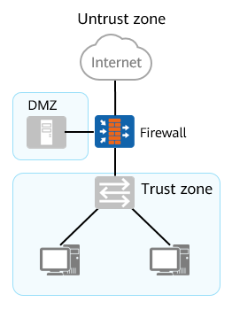

Firewalls

### Wireless devices

In a broad sense, WLAN is a network that uses radio waves, laser, and infrared signals to replace some or all transmission media in a wired LAN. Common Wi-Fi is a WLAN technology based on the IEEE 802.11 family of standards.

On a WLAN, common devices include fat APs, fit APs, and ACs.

AP: Access Point

Generally, it supports the fat AP, fit AP, and cloud-based management modes. You can flexibly switch between these modes based on network planning requirements.

Fat AP: It is applicable to homes. It works independently and needs to be configured separately. It has simple functions and low costs.

Fit AP: It applies to medium- and large-sized enterprises. It needs to work with the AC and is managed and configured by the AC.

Cloud-based management: It applies to small- and medium-sized enterprises. It needs to work with the cloud-based management platform for unified management and configuration. It provides various functions and supports plug-and-play.

AC: Access Controller

It is generally deployed at the aggregation layer of the entire network to provide high-speed, secure, and reliable WLAN services.

The AC provides wireless data control services featuring large capacity, high performance, high reliability, easy installation, and easy maintenance. It features flexible networking and energy saving.

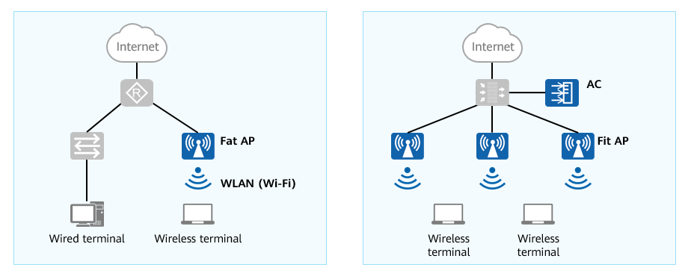

Wireless devices

## Network Types and Topology Types

### LAN, MAN, and WAN

Based on the geographical coverage, networks can be classified into local area networks (LANs), metropolitan area networks (MANs), and wide area networks (WANs).

LAN

A LAN is a network that consists of computers, servers, and network devices in a geographic area. The coverage of a LAN is generally within several thousand square meters.

Typical LANs include a company's office network, a cyber bar network, a home network.

Technologies used: Ethernet and Wi-Fi.

MAN

A MAN is a computer communication network established within a city. A MAN is a large-sized LAN, which requires high costs but can provide a higher transmission rate. It improves the transmission media in LANs and expands the access scope of LANs (able to cover a university campus or city).

The main function is to connect hosts, databases, and LANs at different locations in the same city. The functions of a MAN are similar to those of a WAN except for implementation modes and performance.

Typical MANs include broadband MANs, education MANs, and municipal or provincial e-government private lines.

Technologies used: such as Ethernet (10 Gbit/s or 100 Gbit/s) and WiMAX.

WAN

A WAN generally covers a large geographical area ranging from tens of square kilometers to thousands of square kilometers. It can connect networks of multiple cities or even networks of countries (as an international large-scale network) and provide long-distance communication.

Telecom operators' communication lines are used.

The Internet is a typical WAN.

Technologies used: HDLC and PPP.

### LAN, MAN, and WAN in the Education Industry

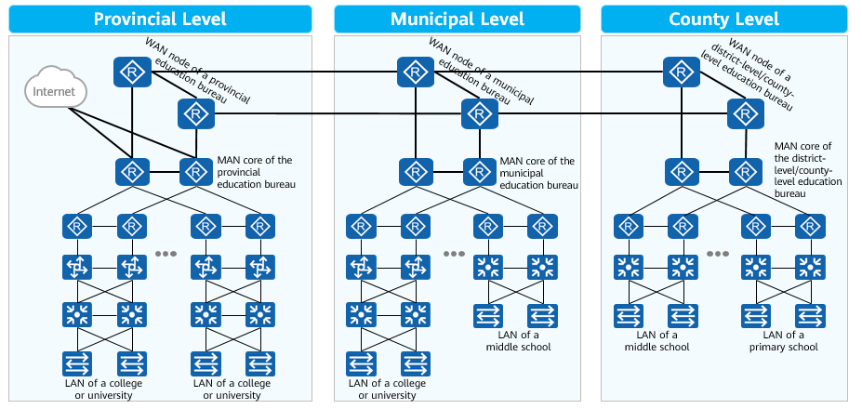

### Network Topologies

A network topology is a structured layout presented using transmission media (such as twisted pairs and optical fibers) to interconnect various devices (such as computer terminals, routers, and switches).

It is very important to master professional network topology drawing skills, which requires a lot of practice.

Visio and Power Point are two common tools for drawing network topologies.

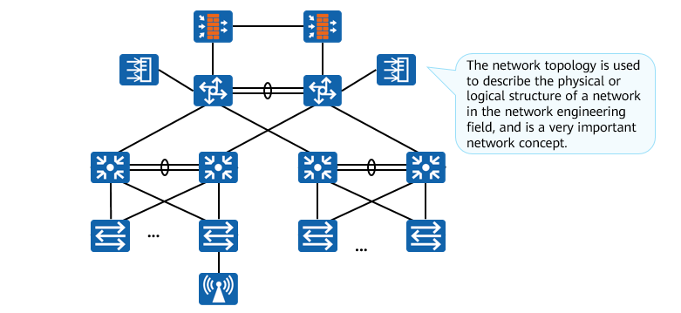

Network Topologies

### Network Topology Types

Network topologies are classified into star, bus, ring, tree, full-mesh, and partial-mesh network topologies.

Star network topology:

All nodes are connected through a central node.

Advantages: New nodes can be easily added to the network. Communication data must be forwarded by the central node, which facilitates network monitoring.

Disadvantages: Faults on the central node affect the communication of the entire network.

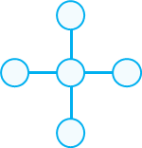

Star network topology

Bus network topology:

All nodes are connected through a bus (coaxial cable for example).

Advantages: The installation is simple and cable resources are saved. Generally, the failure of a node does not affect the communication of the entire network.

Disadvantages: A bus fault affects the communication of the entire network. The information sent by a node can be received by all other nodes, resulting in low security.

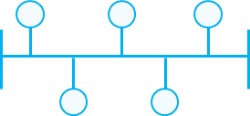

Bus network topology

Ring network topology:

All nodes are connected to form a closed ring.

Advantages: Cables resources are saved.

Disadvantages: It is difficult to add new nodes. The original ring must be interrupted before new nodes are inserted to form a new ring.

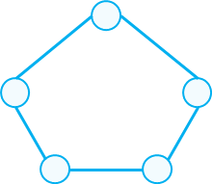

Ring network topology

Tree network topology:

The tree structure is actually a hierarchical star structure.

Advantages: Multiple star networks can be quickly combined, which facilitates network expansion.

Disadvantages: A fault on a node at a higher layer is more severe.

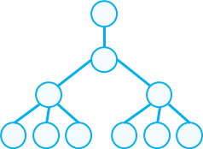

Tree network topology

Full-mesh network topology:

All nodes are interconnected through cables.

Advantages: It has high reliability and high communication efficiency.

Disadvantages: Each node requires a large number of physical ports and interconnection cables. As a result, the cost is high, and it is difficult to expand.

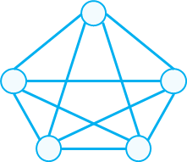

Full-mesh network topology

Partial-mesh network topology:

Only key nodes are interconnected.

Advantages: The cost of a partial-mesh network is lower than that of a full-mesh network.

Disadvantages: The reliability of a partial-mesh network is lower than that of a full-mesh network.

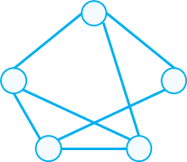

Partial-mesh network topology

In actual networking, multiple types of topologies may be combined based on the cost, communication efficiency, and reliability requirements.

## Network Engineering and Network Engineers

### Network Engineering

Network engineering refers to planning and designing feasible solutions based on network application requirements and computer network system standards, specifications, and technologies under the guidance of information system engineering methods and complete organizations, as well as integrating computer network hardware devices, software, and technologies to form a cost-effective network system that meets user requirements.

Technical modules covered by network engineering:

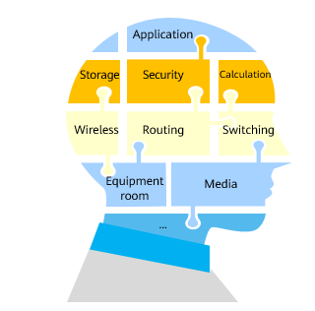

Network engineering technical modules

The knowledge field of network engineering design is very wide, in which routing and switching are the basis of the computer network.

### Network Engineer

Network engineers are technology professionals who master professional network technologies, have professional skills, professionalism, and project implementation experience in the network engineering field, and are able to fully communicate with customers or other project stakeholders onsite. In addition, they can develop implementation solutions and project plans (recognized by project stakeholders) based on customer requirements and environment factors, fully mobilize resources of all parties to ensure timely and high-quality project implementation, and provide training for stakeholders and deliver engineering documents after the project is implemented.

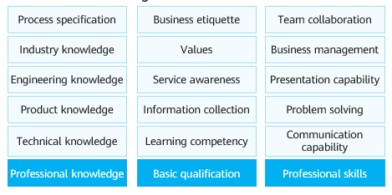

Comprehensive capability models for network engineers

### Network Engineers' Technology Development Path

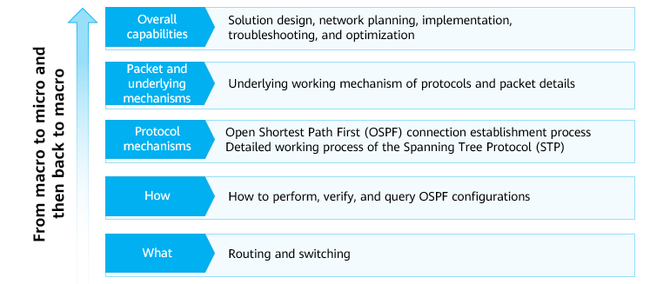

Network Engineers' Technology Development Path

### Huawei Certification Injects Vitality into Talent Development for Enterprises

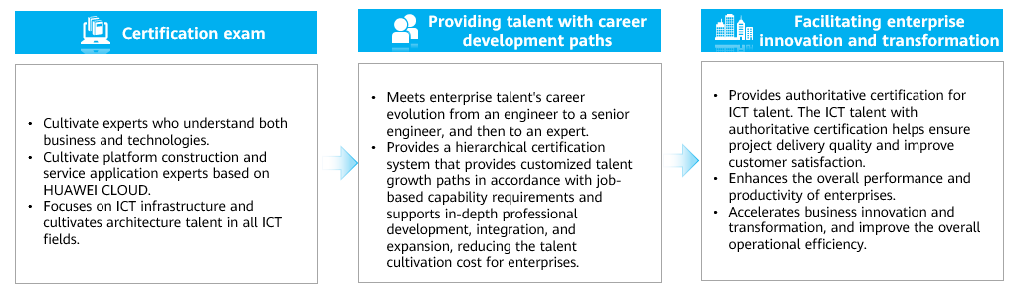

1.6.4 Huawei Certification

### Huawei Certification Portfolio

Huawei certification covers all ICT fields and is committed to providing a leading talent cultivation architecture and certification standards, cultivating ICT professionals in the digital era, and building a healthy ICT talent ecosystem.

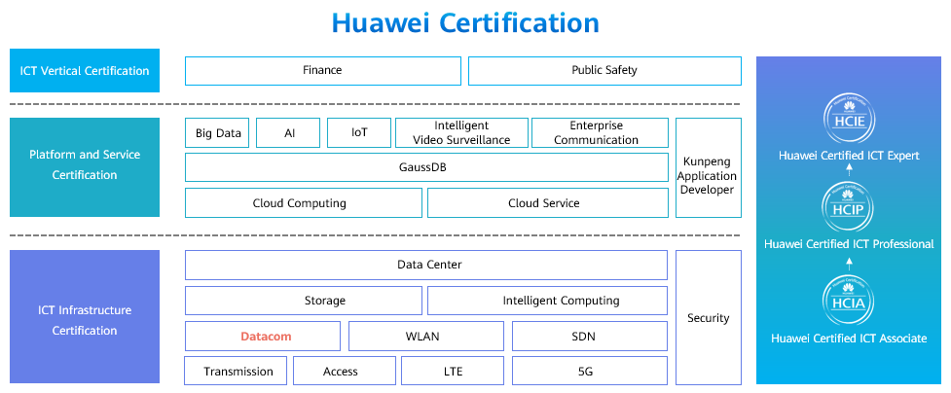

Huawei Certification Portfolio

Huawei talent ecosystem website: https://e.huawei.com/en/talent/#/home

### Huawei Datacom Certification Portfolio

HCIA-Datacom: one course (exam)

Basic concepts of data communication, basis of routing and switching, security, WLAN, SDN and NFV, basis of programming automation, and network deployment cases.

HCIP-Datacom: one mandatory course (exam) and six optional sub-certification courses (exams)

Mandatory course (exam):

HCIP-Datacom-Core Technology

Optional courses (exams):

HCIP-Datacom-Advanced Routing & Switching Technology

HCIP-Datacom-Campus Network Planning and Deployment

HCIP-Datacom-Enterprise Network Solution Design

HCIP-Datacom-WAN Planning and Deployment

HCIP-Datacom-SD-WAN Planning and Deployment

HCIP-Datacom-Network Automation Developer

HCIE-Datacom: one course (exam), integrating two modules

Classic network:

Classic datacom technology theory based on command lines

Classic datacom technology deployment based on command lines

Huawei SDN solution:

Enterprise SDN solution technology theory

Enterprise SDN solution planning and deployment

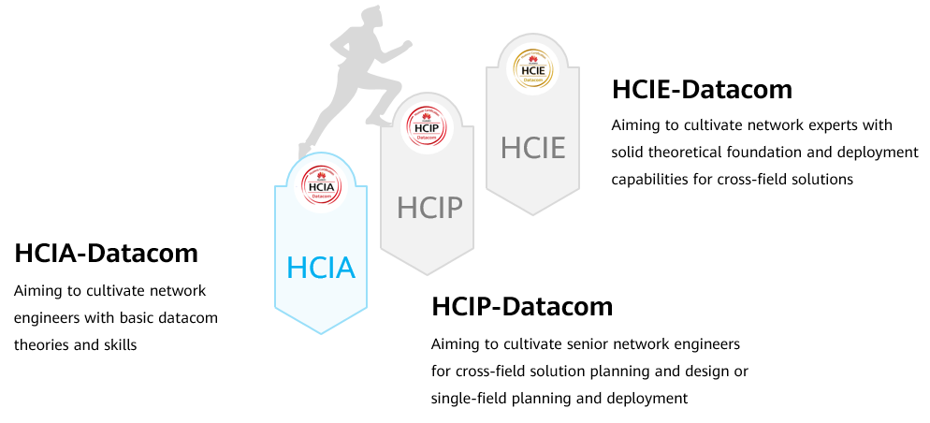

Huawei Datacom Certification Portfolio

## Quiz

1. (Single) Which of the following type of network topology has the highest reliability? ( )
2. Star network topology
3. Ring network topology
4. Full-mesh network topology
5. Tree network topology
6. (Single) Which of the following terms is incorrect? ( )
7. Data payload: information to be transmitted.
8. Encapsulation: A process in which a header and a tail are added to a data payload to form a new packet.
9. Gateway: a network device that provides functions such as protocol conversion, route selection, and data exchange.
10. Terminal: a terminal device in a data communication system that serves as a sender or receiver of data.
11. (Multiple) Which of the following devices are common network devices? ( )
12. Router
13. Switch
14. Firewall
15. Wireless Controller
16. Wireless access point
17. (Multiple) What capabilities do you need to possess as a network engineer? ( )
18. Master professional network technologies.
19. Possess certain professional skills and accomplishments.
20. Have some project implementation experience.
21. Team collaboration capability
22. (True or false) In the network architecture, routers are used to directly connect to terminals. ( )
23. True
24. False
25. (True or false) On a data communication network, we can access the network in wired and wireless modes. ( )
26. True
27. False

## Summary

This section describes the concepts of network communication and data communication network. The basic function of a data communication network is to implement network communication.

This section also introduces various network devices, the differences between LAN, MAN and WAN, and various network topologies. In actual networking, multiple topologies are combined according to the requirements of multiple parties.

This section also describes network engineering and network engineers and introduces Huawei datacom certification system.